***TEST 4***

**PAPER 1: READING AND WRITING** (1 hour 30 minutes)

**READING**

**PART 1**

**Questions 1 – 5**

* Look at the text in each question.
* What does it say?
* Mark the letter next to the correct question – **A**, **B** or **C** – **on your answer sheet**.

**Example**:

**0**



**NO BICYCLES AGAINST GLASS PLEASE**

1. Do not leave your bicycle touching the window.
2. Broken glass may damage your bicycle tyres.
3. Your bicycle may not be safe here.

|  |  |  |  |
| --- | --- | --- | --- |
| **Part 1** | | | |
| 0 | A | B | C |

**Answer:**

**1**

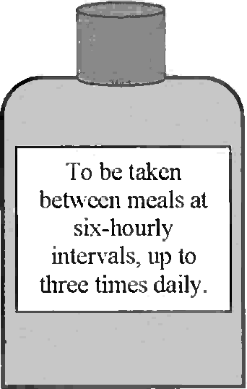

To be taken between meals at six-hourly intervals, up to three times daily

**It is essential**

1. to wait six hours before having more of this medicine.
2. to take this medicine straight after meals.
3. to use this medicine more than three times a day.

**2 What should Louis do?**

Louise,

Suzie rang. The photo shop has lost all her photos of your trip to Vienna and she ‘d like copies of yours.

Mum

1. take some new photos of Suzie
2. give Suzie some photos
3. help Suzie find her photos

**3**

**Basketball Training**

**Professional coach available for pre-booked groups – 48 hours’ notice required**

1. basketball players are only allowed to practise here if accompanied by a professional coach.
2. Basketball training for groups is cancelled until further notice.
3. A basketball coach is available if a booking is made far enough in advance.

**4 How does Sabrina feel about the Plaza Hotel?**

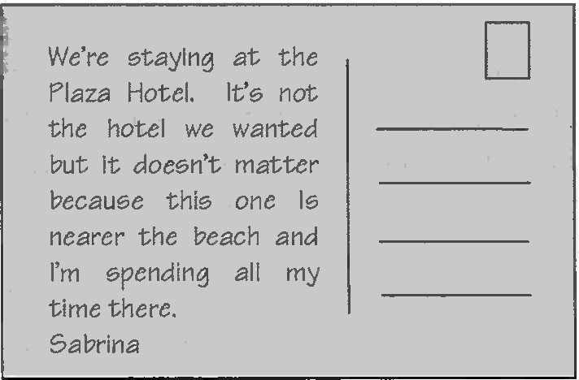

We’re staying at the Plaza Hotel. It’s not the hotel we wanted but it doesn’t matter because this one is nearer the beach and I’m spending all my time there.

Sabrina

1. She’s disappointed with it.
2. She wishes it was nearer the beach.
3. She thinks it has an advantage.

**5**

1. We regret that there are no tickets left for the early performance of Swan Lake.

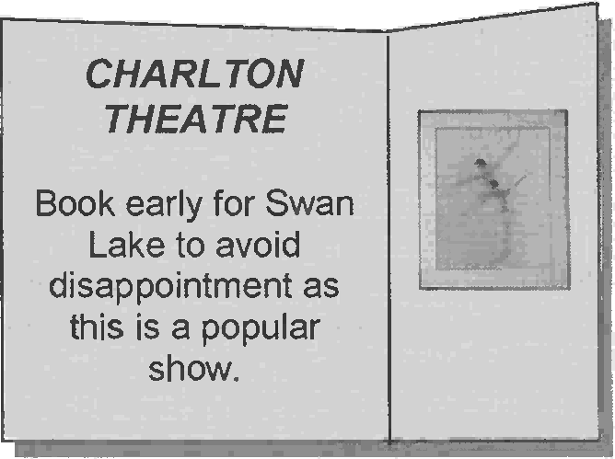

**CHARLTON THEATRE**

Book early for Swan Lake to avoid disappointed as this is a popular show.

1. If you want to see Swan Lake, buy your tickets as soon as possible.
2. Swan Lake is unfortunately cancelled due to disappointed ticket sales.

**PART 2**

**Question 6 – 10**

* The people below all want to buy an audiobook (a book record on CD).
* On the opposite page there are descriptions of eight CDs.
* Decide which museum would be the most suitable for the following people.
* For question **6-10**, mark the correct **(letters A-H)** on your answer sheet.

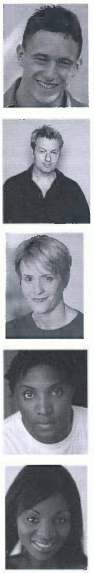

**6** David enjoys spending time in the countryside, exploring different locations and learning about their past. He would enjoy listening to a description of somewhere that he could visit afterwards.

**7** Emile enjoys classical music and drama and is interested in history. He would like to listen to a serious CD that will give information about a particular period of history.

**8** Ysabelle has to drive a lot for her job. She is looking for some amusing fiction to listen to in the car and would like a story that lasts a long time.

**9** Omah is studying literature at university. He is particularly interested in modern poetry and would like to hear some of the poems he knows well being read aloud.

**10**

Tamsin's favourite novels take place in the past, and she likes exciting stories that move fast. She would like a CD that’s easy to listen to and doesn’t last too long.

**Books recorded on CD**

|  |  |
| --- | --- |
| 1. **Hafiz**  Hafiz was a 14th century Persian poet, and on this audiobook his poems are read aloud to a background of instrumental music. Nataraja Kallio reads beautifully. This CD is a great introduction to the work of Hafiz. | 1. **Skulls and Skeletons**   This recording about life in the 11th century was originally a radio series. In addition to the main text, some well-known musicians play instruments from the period, and some important documents and poetry of the time are read by actors. |
| 1. **Coming Home**   Jane Brown decided to take a look at a house for sale near where she grew up. The beauty of the house and the scenery around it amazed her. In this audiobook, she talks about local castles and ruins and gives lots of historical information about the area. | 1. **The Apple Tree**   The Linton’s house has no water or electricity but the beautiful countryside offers them peace and quiet. But when the Dobsons move in next door., things go frighteningly wrong. If you like mystery and suspense, and have plenty of time to listen, this is the novel for you. |
| 1. **Off the Page**   Listening to poems is one of our most ancient traditions and many people still believe that it’s as important to listen to them as it is to read them. Here you can listen to some of the best poems from the 1980s to the present day. This is a great audiobook of you are short of time, as nothing in this collection lasts very long. | 1. **Unlucky**   When Mary Moreton throws herself into the back of George Bennet’s taxi, he falls instantly in love with her. However, she is already in love with someone else. Events move quickly after that and the novel is very funny. You will need several hours for this audiobook but it’s great to listen to while you are busy with other jobs. |
| 1. **Over the Horizon**   Tim falls in love at first sight with Lily when he meets her on an 18th-century prison ship. The ship sinks, he rescues her, and they run away together. The action builds throughout the story. Listeners who enjoy historical adventure will love this book. This is not serious fiction though, and it’s all over pretty quickly | 1. **Mother Learn to Drive**   This is an amusing collection of true stories about growing up in the American countryside. In one particularly funny story, the author describes his mother learning to drive. This is a fairly long audiobook, but it is easy to listen to |

**PART 3**

**Questions 11 – 20**

* Look at the sentences below about Tanya Streeter, a professional diver.
* Read the text on the opposite page to decide if each sentence is correct or incorrect.
* If it is correct, mark **B** on your answer sheet.
* If it is not correct, mark **B** on your answer sheet.

**11** Tanya Streeter’s world record in 2003 was the deepest she had ever dived.

**12** There were other people in the water with Tanya during her record-breaking dive.

**13** Tanya accepts that free-diving can be an extremely dangerous activity.

**14** Tanya’s training programme depends on the event she is preparing for.

**15** Most of Tanya’s training takes place in the water.

**16** Tanya is careful to limit the number of training dives she does in a month.

**17** Tanya spends more time helping environmental organisations than appearing in advertisements.

**18** Tanya’s interest in the natural world started at an early age.

**19** Tanya has found that being famous has its advantages.

**20** Because she started free-diving fairly late, Tanya feels her sports career may be short.

**Free-diving in the Caribbean**

***Tanya Streeter holds four world records in free-diving, the sport in which competition reach extraordinary depths on only one breath of air***.

In 2003, Tanya Streeter made history when she became the first person to dive 120 metres into the ocean while holding her breath, and come back up to the top without help. She had been deeper a year before but on that occasion she swam back up using a balloon. This time, however, she held her breath for over three and a half minutes, which made her the only female in any sport to break the world record of a man. A team of fourteen safety divers at different depths watched the dive.

Following reports of several serious accidents involving other divers, some people have complained that free-diving is too dangerous a sport, but Tanya doesn’t agree, insisting that safety is the most important thing, followed closely by training.

Most free-divers concentrate on one or two types of event within the sport, but whatever Tanya is in training for, her practice timetable remains the same. Two thirds of the programme is spent doing land-based training at the gym, with the rest divided between the pool and the ocean. She uses an exercise bike to help improve the fitness of her heart. However, she doesn’t run, whether outdoors or on running machines, because she doesn’t want to injure her knees. Instead, she finds that fast walking is a very good way to build her fitness. When she starts doing practice dives, she generally travels away from home. She aims to do fourteen dives over a four-week period, with a rest day between each diving day. It is essential that she doesn’t get tired because that could ruin all the preparation.

When Tanya is not preparing for an event, she makes frequent public appearances, mainly to advertise sports products. She has also supported environmental organisations, for example doing research projects or making films. Spending her childhood on the Caribbean island of Grand Cayman, she went swimming whenever she could, and long afternoons were spent exploring rock pools in order to watch the sea life. Tanya says that her life today is like living her childhood dreams. Because she is well-known in some countries, she thinks people are prepared to listen to her when she is talking about environmental issues.

As for the future, Tanya, who is now in her thirties, says she plans to keep breaking her own world records. As she didn’t take up free-diving until she was twenty-five, Tanya is keen to stress that she doesn’t intend to retire from the sport for many years to come.

**PART 4**

**Questions 21—25**

* Read the text and questions below.
* For each question, mark the letter next to the correct answer — **A, B, C** or **D** on your answer sheet.

**Little Chefs**

For one group of children aged between ten and fifteen, Saturdays are spent learning the art of serious cooking. Their weekly lessons in small classes are so popular that there is a waiting list of 30 children who want to do the course.

Parents pay £280 for the course where their children can have fun and learn how to make good food.

Class member Bill, aged ten, says, ’I love my mum’s cooking and now I can do it better than her. The teachers make us laugh, especially when we sit down with them to share the food we’ve made.’

Flora is twelve, and she’s having problems preparing onions. ‘I love cooking. I did a meal for ten friends which they really enjoyed. Then my mum suggested I take up a hobby, instead of doing nothing at weekends. I was happy staying at home, so I wasn’t too keen at first. I’m really glad I decided to come, though.’

Their teacher, Philippe, says, ‘It’s great fun. Children pay attention and remember things better than adults, although the kitchen isn’t always as tidy when they’re cooking! As adults, we’re always learning more about food. If parents interest their children in cooking while they are young, they’ll have enough skill to make food for themselves when they leave home.’

**21** What is the write trying to do in the text?

1. warn parents not to expect too much from their children
2. advertise schools that teach people how to cook
3. describe how some children spend their spare time
4. explain why parents want to learn more about cooking
5. What can a reader find out from this text?
6. which dishes students prefer to cook on the course.
7. why the classes are so successful.
8. how much one lesson costs.
9. when the next classes begin.

**23** Why did Flora join the course?

1. Her friends persuade her to do it.
2. She wanted to learn to cook a big meal.
3. She felt bored at weekends, with nothing to do.
4. Her mother wanted her to develop an interest.

**24** What does Philippe say about his young students?

1. They will be confident about cooking in the future.
2. They have a good memory but don’t always listen.
3. They keep the kitchen cleaner than adults do.
4. They teach their parents what they have learnt in class.

**25** What would one of Philippe’s students say to a friend?

**A B**

We made onion soup yesterday. The course is great, although there are 30 people in my class.

I go every Saturday, and now I can cook as well as my mum. I’m ten, and I’m the oldest

**C D**

It’s great. No one’s over 15 and the food looks delicious. I just wish we could eat it together instead of taking it home.

I was on a waiting list for ages, but now I’m on the course. Last week I cut up some onions – it was hard!

**PART 5**

**Questions 26—35**

* Read the text below and choose the correct word for each space.
* For each question, mark the letter next to the correct word — **A, B, C** or **D** — on your answer sheet.

**Example:**

|  |  |  |  |  |
| --- | --- | --- | --- | --- |
|  | | | | |
| **0** | **A** | **B** | **C** | **D** |

**0 A** was **B** is **C** has **D** had

**Answer**

San Francisco

San Francisco lies (0) .......................................... the coast of northern California. The earliest Europeans to discover the (26) .......................... were led by a Spanish explorer (27) ........................ name was Gaspar de Portola.

He first saw it in 1769. Surprisingly, (28) ........................ San Francisco Bay is a wonderful

natural harbour, it was discovered by land (29) ........................ than by sea.

In 1849, people (30) ........................ in San Francisco in their thousands (31) ….to

find gold. However, it was not the men looking for the gold that got rich. The richest people (32) ........................ their money from owning banks and law firms and they built themselves large houses on one of the hills. This was (33) ........................ as Nob Hill.

Nowadays, tourists are (34) .............. ......... to San Francisco because there they can see famous places like Chinatown and the Golden Gate Bridge. Many even (35) ........................

the short boat trip to the island of Alcatraz to see the former prison.

|  |  |  |  |  |  |  |  |  |
| --- | --- | --- | --- | --- | --- | --- | --- | --- |
| **26** | **A** | area | **B** | part | **C** | space | **D** | position |
| **27** | **A** | who | **B** | whose | **C** | what | **D** | which |
| **28** | **A** | if | **B** | unless | **C** | although | **D** | despite |
| **29** | **A** | except | **B** | instead | **C** | apart | **D** | rather |
| **30** | **A** | reached | **B** | arrived | **C** | entered | **D** | approached |
| **31** | **A** | wondering | **B** | hoping | **C** | considering | **D** | depending |
| **32** | **A** | did | **B** | became | **C** | made | **D** | brought |
| **33** | **A** | told | **B** | called | **C** | named | **D** | known |
| **34** | **A** | interested | **B** | attracted | **C** | pleased | **D** | excited |
| **35** | **A** | take | **B** | spend | **C** | go | **D** | travel |

***Visual material for the Speaking test***

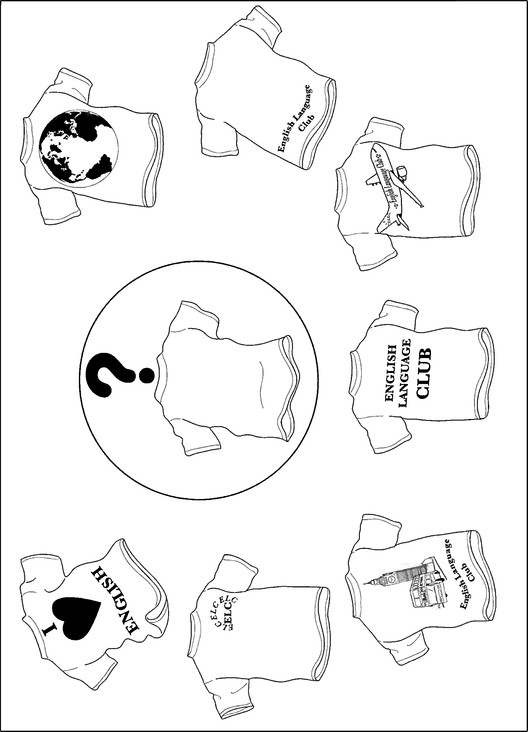1A

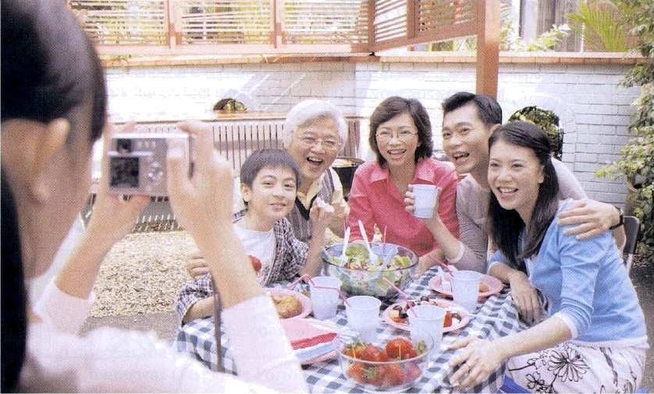1B

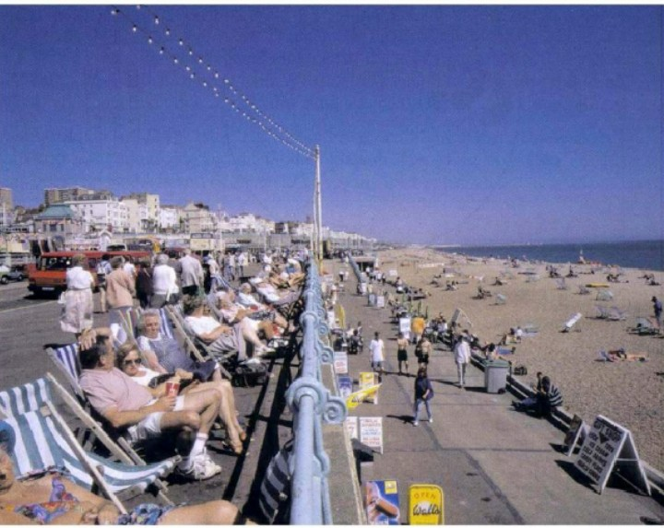2C

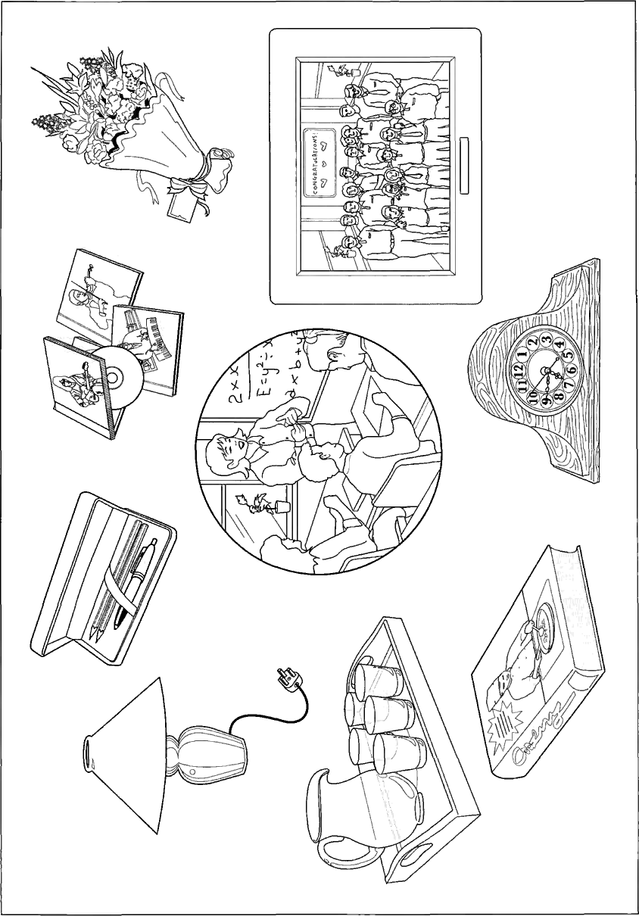

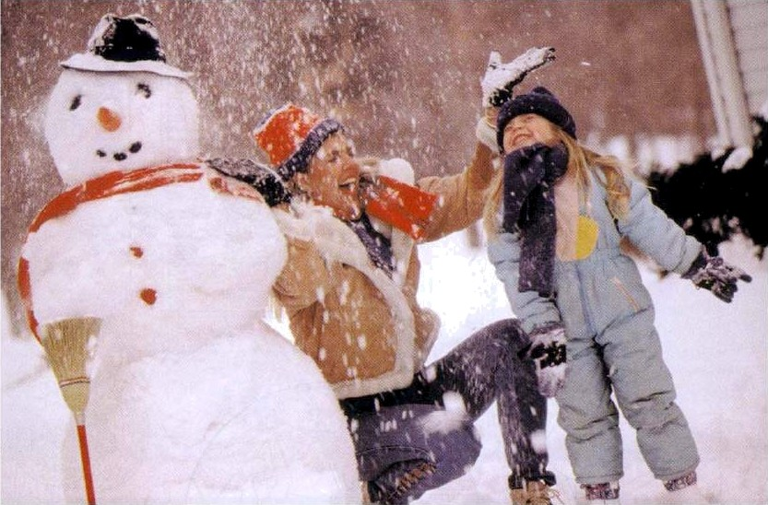2B

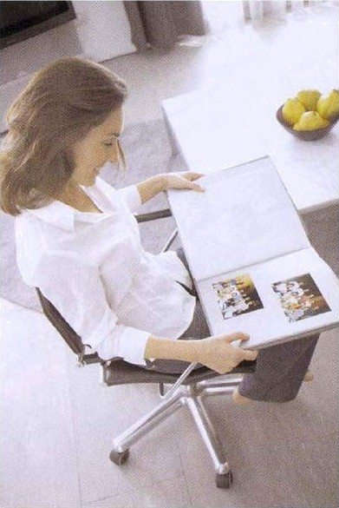

1C

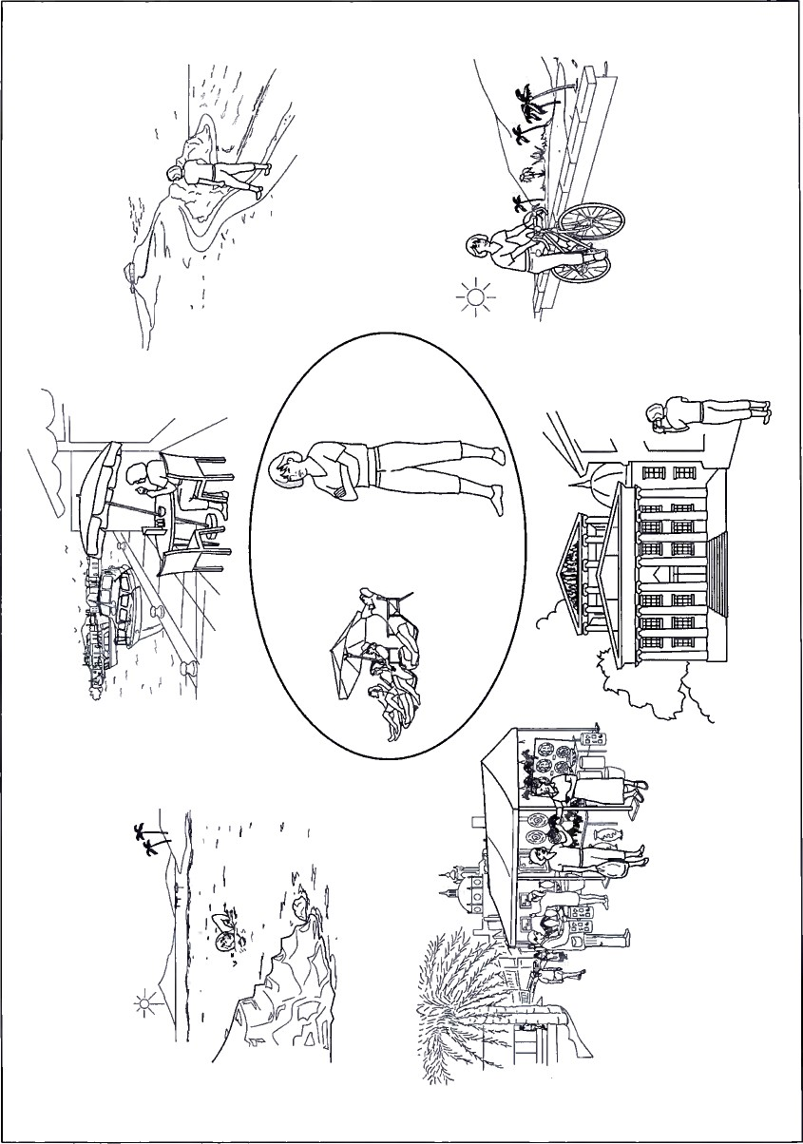3A

3B

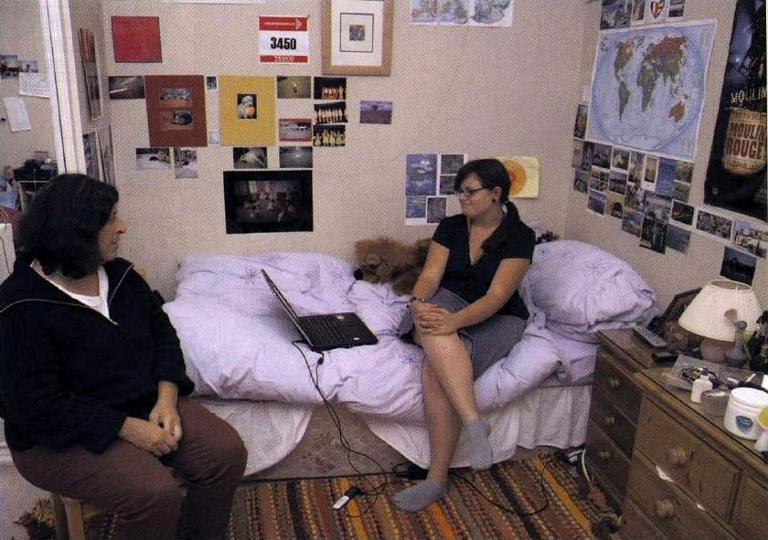4C

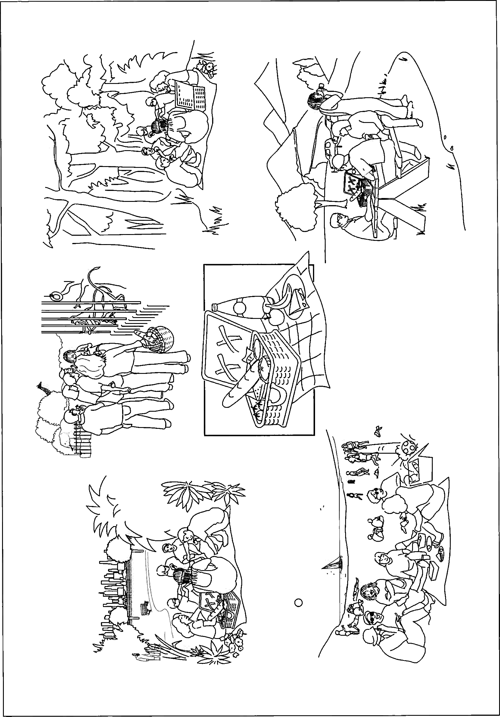4A

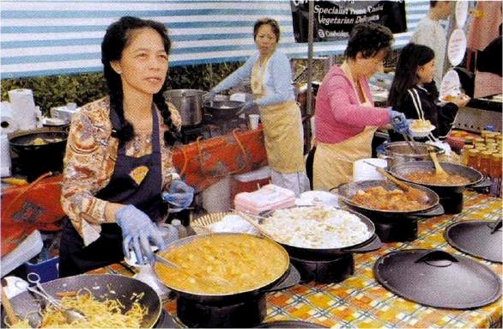3C

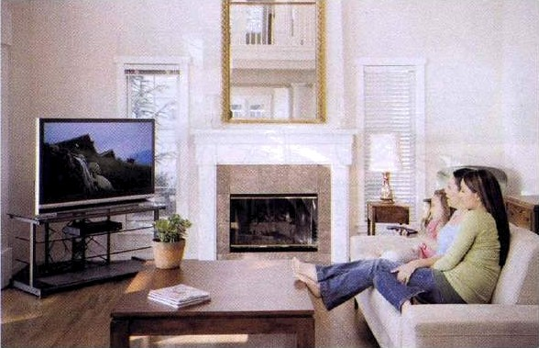 4B

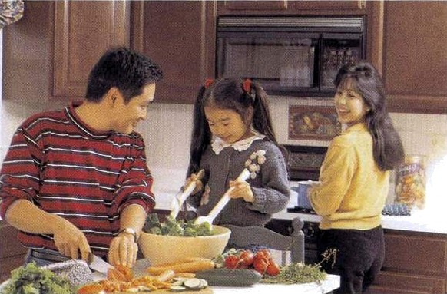4D

**WR ITING**

**PART 1**

**Questions 1—5**

* Here are some sentences about a camping holiday.
* For each question, complete the second sentence so that it means the same as the first.
* **Use no more than three words.**
* Write only the missing words on your answer sheet.
* You may use this page for any rough work.

**Example:**

1. Sebastian had never been camping before.

**This was………………………………………. Sebastian had been camping.**

**Answer:**

**0** the first time

1. The campsite was not far from the sea.

**The campsite was quite…………………………………………......the sea.**

1. Sebastian asked the manager where the showers were.

**Sebastian asked the manager, ‘Where showers?’**

1. Sebastian succeeded in putting up the tent on his own.

**Sebastian was able………………………...…………… up the tent on his own.**

1. Sebastian and his friends went swimming every day.

**Every day Sebastian went swimming and……………………... did his friends**

1. The sea was warmer than they had expected.

**The sea was not as……………………………………………. they had expected.**

**PART 2**

**Question 6**

You are going to miss your English class tomorrow.

**Write a note to your English teacher. In your note, you should**

* + **apologise for missing tomorrow’s class**
  + **explain why you can’t be there**
  + **suggest what you could do to cover the work you miss.**

**Write 35—45 words on your answer sheet.**

**PART 3**

Write an answer **one** of the following questions (**7** or **8**).

Write your answer in about **100 words** on your answer sheet.

Mark the question number in the box at the top of your answer sheet.

**Question 7**

* This is part of a letter you receive from an English penfriend.



I’ve just bought some new trousers. They’re black and I really like them. Tell me about the clothes you like wearing. Do you enjoy shopping for clothes?

* Now write a letter to your penfriend’s about clothes.
* Write your **letter** on your answer sheet.

**Question 8**

* Your English teacher has asked you to write a story.
* This is the title for your story:

The lost suitcase.

* Write your **story** on your answer sheet.

**PAPER 2 LISTENING TEST** about 35 minutes

(including 6 minutes transfer time)

**PART 1**

**Questions 1-7**

* There are seven questions in this part.
* For each question there are three pictures and a short recording.
* Choose the correct picture and put a tick (✓) in the box below it.

**Example:** Where did the man leave his camera?

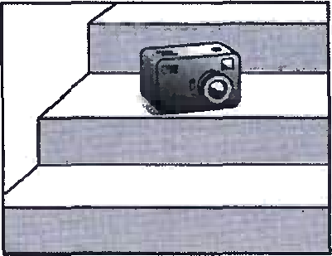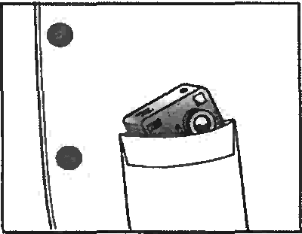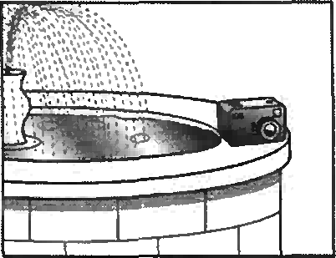

**A B C**

✓

1. Which of Miranda’s things will Lucy be able to use?

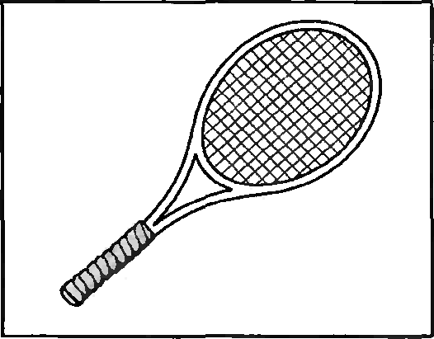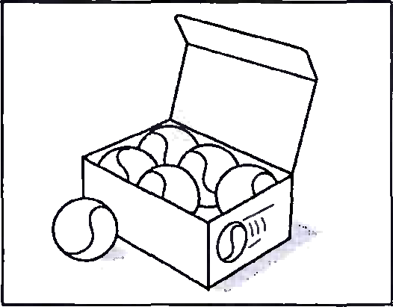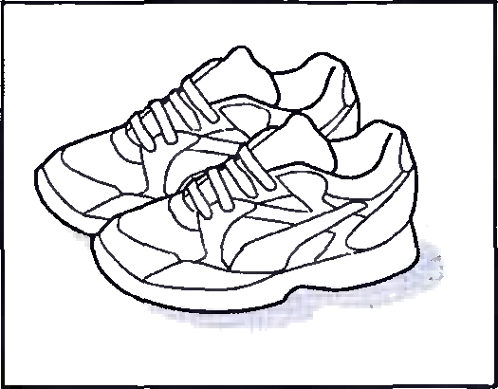

**A B C**

1. What can’t the woman find?

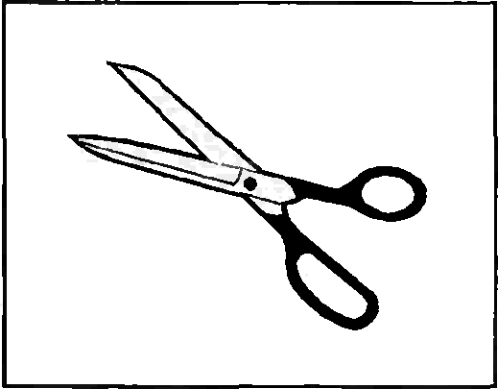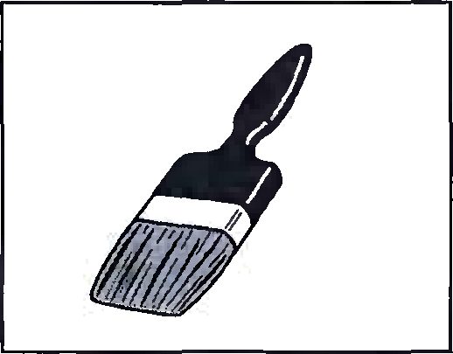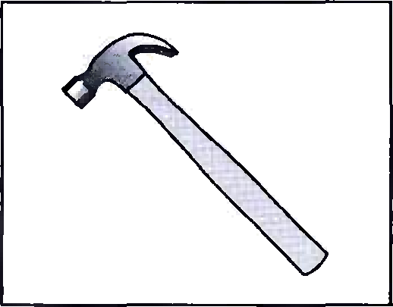

**A B C**

1. Which ring has the woman lost?

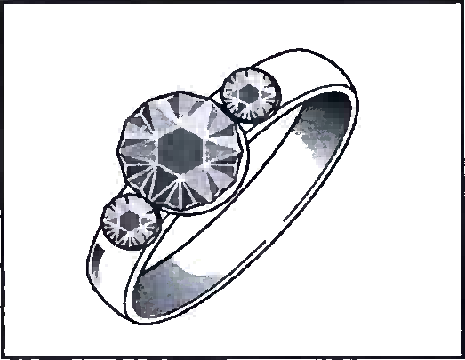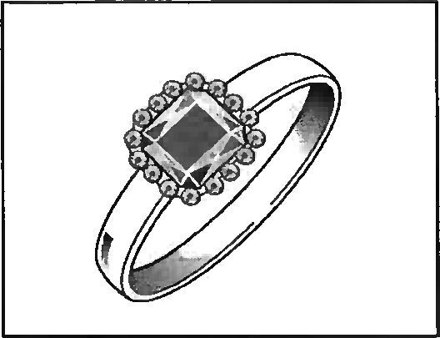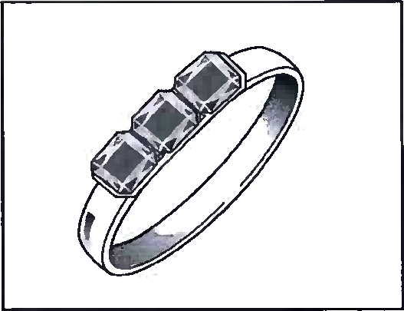

**A B C**

1. What time did the girl arrive?

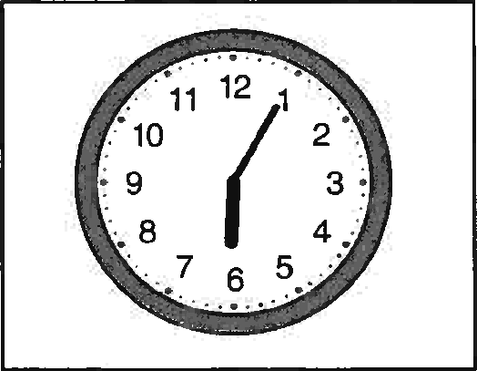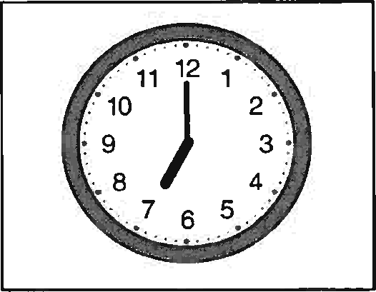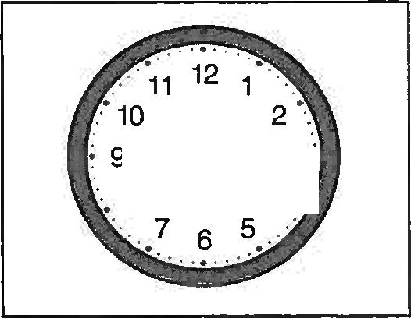

**A B C**

1. What will be on television at 10 o’clock this evening?

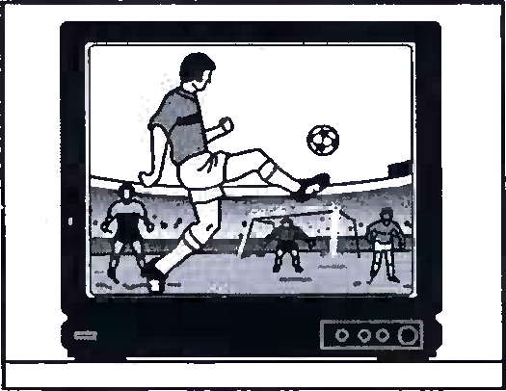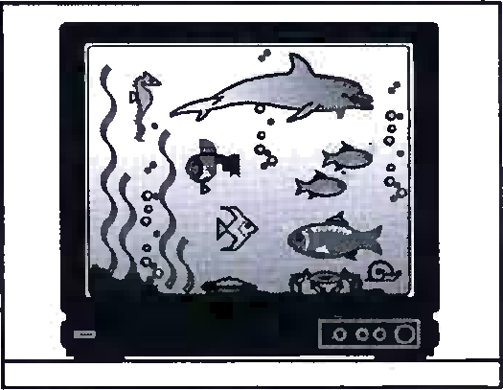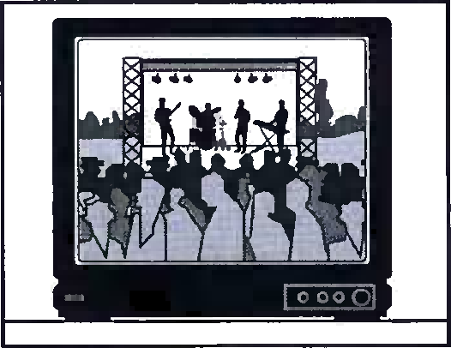

**A B C**

1. Where will the party be?

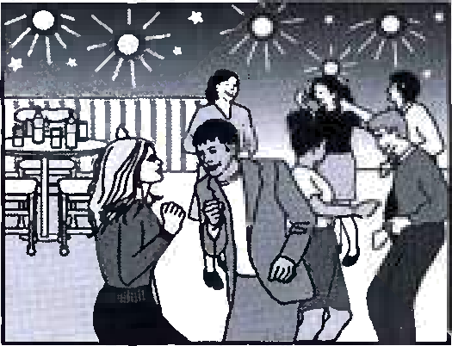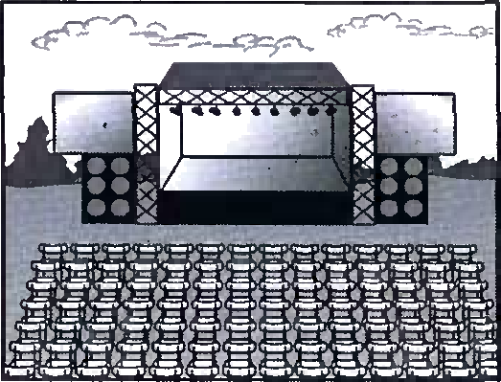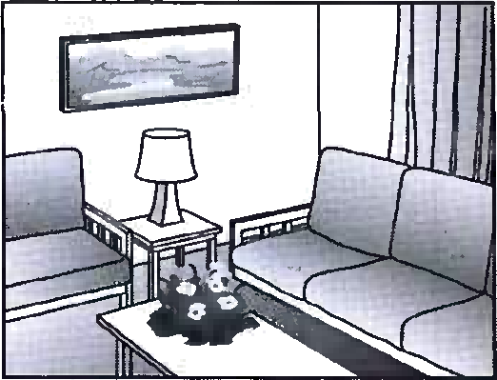

**A B C**

**7** What did the man buy?

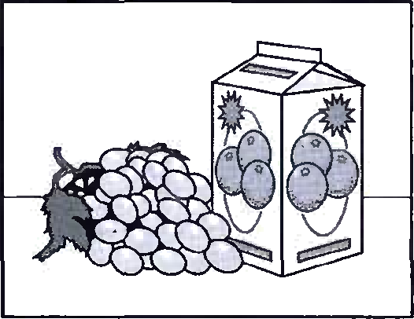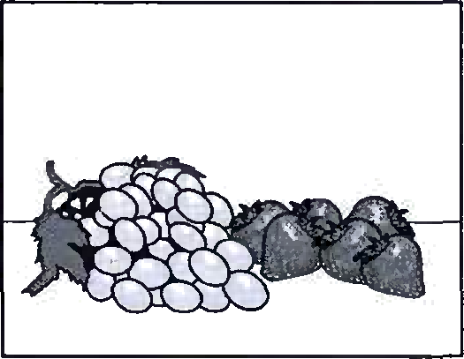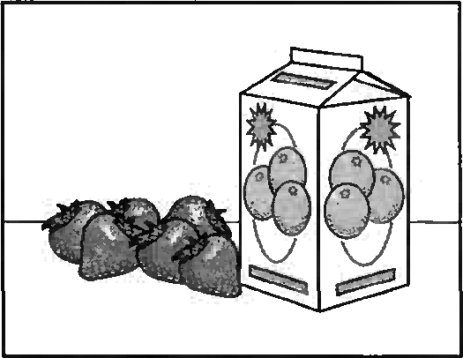

**A B C**

**PART 2**

**Question 8 -13**

* You will hear a man called Paul Hart talking about his trip to Africa with a team of scientists.
* For each question, put a tick (✓) in the correct box.

**8** Why did Paul choose the part of Africa he visited?

1. It is good for walking.
2. It will soon change.
3. He had been there before.

**9** What made the team’s journey slow?

1. clearing paths through the forest
2. finding somewhere safe to camp
3. carrying heavy equipment

**10** What did Paul worry about during the trip?

1. the number of dangerous animals
2. getting the information he needed
3. being responsible for a team of people.

**11** Paul says that the team didn’t have enough food becasue

1. some people ate more they should.
2. the walk took longer than expected.
3. some of the food went bad too quickly.

**12** Why were the team grateful to a fisherman they met?

1. He let everyone rest on his boat ill
2. He helped one of them who was
3. He told them which direction to take.

**13** How does Paul feel now he is back home?

1. He is planning to do another trip.
2. He misses the people in the team.
3. He thinks the trip was a valuable experience.

**PART 3**

**Question 14 – 19**

You will hear a woman talking about flights in a hot air balloon.

For each question, fill in the missing information in the numbered space.

Hot Air Balloon Flights

Children under 12 must be with an adult.

All passengers need to be **(14)** ………………………

Balloon flight are best when there are

light winds, no **(15)** ………….and a clear sky.

Passengers need to wear outdoor clothes and **(16)**………………

Flights travel between 5 and 30 kilometres.

Passengers return to the airfield in a **(17)** ………………

Flights are available from the month of **(18)** ………each year.

For booing and information, phone **(19)** ………………………

or visit www.hotairballoon.com

**PART 4**

**Questions 20-25**

* Look at the six sentences for this part.
* You will hear a conversation between a girl called Ella, and her father, about the school holidays.
* Decide if each sentence is correct or incorrect.
* If it is correct, put a tick (✓) in the box under **A** for **YES**. If it is not correct, put a tick (✓) in the box under **B** for **NO**.

A B

YES NO

1. Ella and her father both think she has worked hard.
2. Ella is happy to be alone during the holidays.
3. Ella has a lot in common with her friends.
4. The family’s last camping trip was unsuccessful.
5. Someone has asked Ella to look after a horse in the holidays.
6. Ella’s father is keen for her to spend the holidays relaxing.

***Key***

**PAPER 1 READING AND WRITING**

**READNING**

Part 1

1A 2B 3C 4C 5B

PART 2

6C 7B 8F 9E 10G

PART 3

11B 12A 13B 14B 15B 16A 17B 18A 19A 20B

PART 4

21C 22B 23D 24A 25D

PART 5

26A 27B 28C 29D 30B 31B 32C 33D 34B 35A

**WRITING**

PART 1

1. near/close to
2. are the
3. to put
4. so
5. cold as

**PAPER 2 LISTENING**

PART 1

1B 2C 3B 4B 5A 6C 7C

PART 2

8B 9A 10C 11A 12B 13C

PART 3

14 fit

15 rain

16 boots

17 mini - bus

18 March

19 0125288492

PART 4

20A 21A 22B 23A 24B 25B